INST-134

U.S. Import Instruction for Suppliers
SNC PROPRIETARY INFORMATION
Level: | Corporate | Authorized By: | General Counsel
Type: | Instruction | Site(s): | All
Owning Org: | ITCO | Applicable To: | Legal, Supply Chain
DOCUMENT INFORMATION

REVISION INFORMATION
Rev | Effective | Summary of Changes | Sections Revised
A | 7/1/2020 | Minor – 02/22/2023 - Biennial Review. No content changes made. Renumbered to align with new numbering format. Formerly G&A-INST-134 | N/A
Prior | *See Document Administrator for details*
 | Next Review Date 02/23/2025

GOVERNING DOCUMENT
G&A-PRCD-120 International Trade Compliance
EXTERNAL REGULATIONS / STANDARDS
https://www.ecfr.gov/cgi-bin/text-idx?SID=37fa2485c7dd242898754b52220627bf&mc=true&tpl=/ecfrbrowse/Title19/19tab_02.tpl
https://iccwbo.org/resources-for-business/incoterms-rules/incoterms-2020/

TABLE OF CONTENTS
1 PURPOSE 3
2 SCOPE 3
3 DOCUMENT PREPARATION 3
3.1 Air Waybill (AWB) 3
3.2 Commercial Invoice (CI) 3
3.3 Certificate of Origin, Free Trade Agreement Certificate of Origin and other Tariff Terms 4
3.4 Incoterms® 2020 5
3.5 Documentation Distribution 5
3.6 Preferred Couriers/Freight Forwarders 5
4 GLOSSARY OF TERMS/ACRONYMS 6
APPENDIX A: SAMPLE COMMERCIAL INVOICE 7

PURPOSE
The purpose of this document is to provide instructions to Sierra Nevada Corporation (SNC) international suppliers. These instructions are intended to ensure efficient and timely delivery of cargo from international suppliers to SNC. These instructions are the default requirement, but may be superseded or altered in part by individual contracts negotiated between SNC and a supplier.
These instructions help ensure that SNC remains compliant with all U.S. import, as well as SNC’s internal requirements. Failure to follow these requirements may result in unexpected delays, unnecessary cost increases, U.S. Government inspections, or fines / penalties for regulatory non-compliance.
*For assistance with any import into the U.S. please contact the SNC International Trade Compliance Operations team at ITCOOperations@sncorp.com

SCOPE
This information will assist SNC suppliers shipping from outside of the U.S. to SNC locations within the U.S. These instructions are not a substitute for compliance with applicable governmental regulations. If a supplier is designated as the Importer of Record, it is their legal responsibility to understand and comply with import laws and regulations of the appropriate countries. SNC is not responsible for the supplier’s failure to follow applicable export/import requirements when they are the exporter/importer of record.

DOCUMENT PREPARATION
All documents must be prepared accurately in English and be clearly legible. SNC requirements on preparing documents for U.S. Import are detailed below.

Air Waybill (AWB)
- Must be prepared in English.
- Supplier shall prepare the AWB for courier shipments. The supplier shall provide the forwarder/carrier with the information necessary to prepare the AWB for air freight and ground shipments.
- AWB must include the following:
- Forwarder/carrier name and address
- Foreign supplier complete name and address
- Seller complete name and address
- Sierra Nevada Corporation purchase order number
- Ship-to consignee/delivery destination complete name and address
- Notify party
- Gross and net weight

Commercial Invoice (CI)
The Commercial Invoice must be complete in accordance with U.S. law, 19 CFR § 141.86. The specific requirements include:
- The foreign supplier must prepare each CI
- All items in a shipment must be declared on a CI
- The CI must be in English
- The CI must include the following:
- Seller’s (i.e. exporter’s) complete company name and address, including contact name, telephone and email address
- Buyer’s (i.e. importer’s) complete name and address
- Consignee’s (i.e. ship-to-party’s) complete company name and address, including contact name, telephone number, and email address
- Shipper’s (i.e. “ship from”) complete company name and address, if different from seller
- Terms of sale/freight payment terms as defined on the agreement between buyer/seller
- Sierra Nevada Corporation purchase order number
- Currency must be in USD
- Assists (tools, dies, molds, engineering, etc. – see GLOSSARY OF TERMS/ACRONYMS)
- Line Items:
- Detailed description of products, including name by which each part is known, model number(s), material and part numbers
- Country of origin
- Quantities
- Purchase price
  - “No charge” product(s) must declare actual value for U.S. Customs clearance
- Commodity HTSUS number

Certificate of Origin, Free Trade Agreement Certificate of Origin and other Tariff Terms
In order for SNC to take advantage of reduced duty benefits under free trade agreements such as United States-Mexico-Canada Agreement (USMCA), the seller/supplier must create a properly executed Certificate of Origin (COO). The products sold to SNC must qualify as “originating” under those agreements. The seller/supplier must maintain documentation supporting the COO for 5 years from the date of export.
If products do not qualify for a special program, the seller/supplier shall provide the correct country of origin or where the last “substantial transformation” occurred.
For assistance in determining if the product being imported qualifies for a special program, please contact the SNC ITCO Operations team at ITCOOperations@sncorp.com.
Suppliers/sellers are responsible for identification of hazardous materials and compliance with all applicable hazardous material transportation regulations, including, but not limited to:
- Code of Federal Regulations (CFR)
- International Civil Aviation Organization (ICAO),
- Agreement concerning the international carriage of Dangerous Goods by Road (ADR)
- International Air Transport Association
Suppliers/Sellers are also required to supply the Material Safety Data Sheets (MSDS) for all applicable hazardous and non-hazardous materials.

Incoterms® 2020
In the absence of Incoterms® elsewhere found on SNC’s purchase orders, agreements, or contracts, the preferred Incoterms® shall be: (1) Free Carrier – FCA (Port Location) or (2) DAP (Port Location).

Documentation Distribution
The supplier/seller is required to provide copies of all shipping documents to SNC’s designated courier/freight forwarder at the time of pick-up or delivery. Required documents and information include the CI and AWB. If applicable, COO, MSDS, and/or Declarations of Dangerous Goods must be provided.

Preferred Couriers/Freight Forwarders
SNC’s consistent couriers and freight forwarders are listed below. If you need to use an alternative courier or freight forwarder, contact the SNC ITCO Operations team at ITCOOperations@sncorp.com.
Courier **Under 150 lbs.** | Freight Forwarders **Over 150 lbs.**
FedEx | FedEx
DHL Express | JAS
 | Crane World Wide

GLOSSARY OF TERMS/ACRONYMS
Acronym, Abbreviation or Term | Definition | Term Source  (SNC, Military/Government, or Industry)
Assist | (1) “Assist” means any of the following if supplied directly or indirectly, and free of charge or at reduced cost, by the buyer of imported merchandise for use in connection with the production or the sale for export to the United States of the merchandise:  (i) Materials, components, parts, and similar items incorporated in the imported merchandise.  (ii) Tools, dies, molds, and similar items used in the production of the imported merchandise.  (iii) Merchandise consumed in the production of the imported merchandise.  (iv) Engineering, development, artwork, design work, and plans and sketches that are undertaken elsewhere than in the United States and are necessary for the production of the imported merchandise.  (2) No service or work to which paragraph (a)(1)(iv) of this section applies will be treated as an assist if the service or work:  (i) Is performed by an individual domiciled within the United States;(ii) Is performed by that individual while acting as an employee or agent of the buyer of the imported merchandise; and  (iii) Is incidental to other engineering, development, artwork, design work, or plans or sketches that are undertaken within the United States.  (3) The following apply in determining the value of assists described in paragraph (a)(1)(iv) of this section:  (i) The value of an assist that is available in the public domain is the cost of obtaining copies of the assist.  (ii) If the production of an assist occurred in the United States and one or more foreign countries, the value of the assist is the value added outside the United States.  (iii) If the assist was purchased or leased by the buyer from an unrelated person, the value of the assist is the cost of the purchase or of the lease. | U.S. Customs and Border Protection (19 CFR 152.102)

APPENDIX A: SAMPLE COMMERCIAL INVOICE
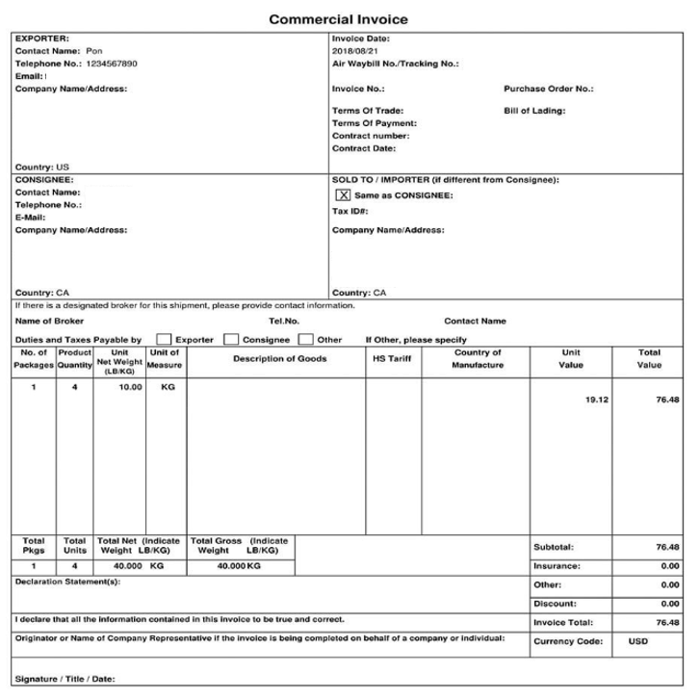

*For assistance with any import into the U.S. please contact the SNC International Trade Compliance Operations team at ITCOOperations@sncorp.com

